H53PJ3

Final Year Project Report

**DEPARTMENT OF ELECTRICAL AND**

**ELECTRONIC ENGINEERING**

“Hands-free" control of a Quadcopter

AUTHOR: NANDI GUO

ID NUMBER: 14311495

SUPERVISOR: Dr. Steve Greedy

MODERATOR: Dr. James Bonnyman

DATE: 04/03/2020

**Abstract**

The quadcopter is generally controlled by a handheld remote controller which could be a challenge for beginners. Research has shown that most of the beginners don’t have enough knowledge about the fly modes of a copter (Throttle, pitch, yaw, roll) and each function of the joystick on the complex handheld controller. This project aims to remotely control a Quadcopter by using a gesture recognition sensor to bring a new and easier control concept for users. Building on existing work on the targeted project, it asks: Which kind of gesture sensors would be used, how the quadcopter is controlled by the sensor and how the signal could be transferred to the quadcopter?

A hand gesture sensor called Leap-Motion would be used as a control component, users could control the quadcopter easily by wave their hands, the height of the hand determines the flying height, and the plane position of the hand determines the flying direction. The signal generated by the gesture sensor would be sent to a microcontroller which is able to control the mechanical components on the original handheld controller.

Analysis of the long-term project experiment demonstrated that gesture sensor could achieve a relatively precise control method of the quadcopter, users can quickly learn to control drones with their own hands without a lot of practice and they won’t feel boring about the learning process.

Table of Contents

Chapter 1: Introduction 4

Section 1.1: An Introduction 4

Section 1.2: Background 4

Section 1.3: Objective of the Project 7

Chapter 2: Components selection 8

Section 2.1: Gesture sensor 8

Section 2.2: Quadcopter and Transmitter 9

Section 2.3: Microcontroller choose 11

Section 2.5 SG90 servo motor/5v torque motor choose 12

Section 2.7 Power supply 15

Chapter 3: Project design concept and analysis 15

Section 3.1: Project design concept 1 15

Section 3.2: Project design concept 2 19

Section 3.3: Project design concept 3 22

Section 3.4 Project design concept analysis 24

Chapter 4: Project design concept 3 implementation 24

Section 4.1: Hardware design 24

Chapter 5: Software design 27

Section 5.1: SG90 servo motor test 27

Section 5.3: “Processing 3” IDE with Leap Motion 28

Section 5.4: Communication code 30

Chapter 6: system evaluation 32

Section 6.1 System mechanism 32

Section 6.2 Integration of SG90 board with a handheld controller 33

Section 6.3 Increasing the recognize precision of processing 3 (Leap motion) 35

Section 6.4 System evaluation 36

Chapter 7: Future Work 38

# Chapter 1: Introduction

## Section 1.1: An Introduction

The popularity of quadcopter has been increasing in recent years. The quadcopter is a complicated flying mechanic's vehicle that has four arms, and there is a motor attached to a propeller in every arm. The quadcopter is normally controlled by a handheld radio remote controller. Using the original remote controller to control the quadcopter will be a challenge for beginners. This project aims to remotely control a Quadcopter by using a gesture recognition sensor. Therefore achieving ‘hands-free' control for the users.

The aims of the project are listed:

1. This project aims to offer a human interface instead of the traditional radio controller.
2. The traditional remote controller should be modified and connected to the gesture recognition sensor and the sensor should be able to control the quadcopter to fly.
3. A flight control system of gesture recognition should be implemented.
4. Complete and try to upgrade the control system.

## Section 1.2: Background

* **Gesture recognition**

A sensorial computing user interface that allows machines to Identify and calculate human gestures as commands are gesture recognition. In general, the explanation of gesture recognition is the capability of a computer to comprehend gestures then perform commands according to human gestures. Consumers are familiar with gesture recognition through VR devices and X-box or PlayStation games. In the gesture recognition area, gestures are defined as physical movement, it could be large movement or small movement, these movements can be recognized by a gesture sensor. It includes anything from the points of fingers to a nod of the head to a pinch or roundhouse kick or wave of the hand. Gestures may be contained or broad. In some instances, the definition of the gesture may also include voice.

A general way is cameras send picture data into a sensor that is connected to a computer. The sensors then use an infrared sensor for measuring depth.

Gesture recognition software identifies gestures from a predetermined library where all gestures are already matched to a computer command.

The software will correlate every real-time gesture, recognizes the gesture and take the library to identify various gestures that coincide with the library. As soon as the gesture was interpreted, the computer runs the command correlated to that particular gesture.

Currently, gesture recognition technology has three mature solutions: "structure light", "time of flight" and "multi-camera". [1]

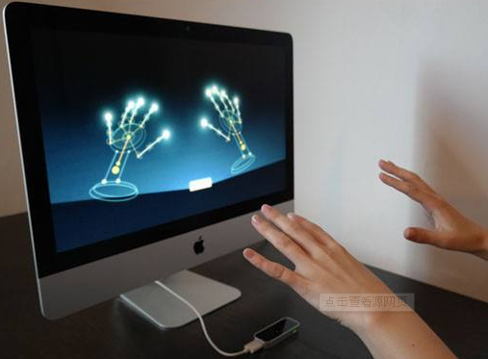Overall, using gesture recognition could Greatly improve the precision of human control of the machine and Simplifies the way humans interact with machines. Using gesture recognition for remote control also brings a whole new experience for humans.

Figure 1: gesture recognition

* **Gestures detected methods**

According to different hardware implementations, there are about the following gesture recognitions used in the industry:

a. Structure Light, which calculates the location and depth data of an object with laser refraction and algorithm, thus restoring the whole three-dimensional space. Typical products of structured light are Microsoft's Kinect generation [2]. However, since the location of the refracted light was calculated to calculate the location, this technique cannot compute accurate depth data, and there are stringent requirements for the distance to be recognized.

b. Time of Flight, charging a light-emitting component, capturing the flight time of the calculated photon through the CMOS sensor, and calculate the distance of the photon flight that is based on a photon flight time, and receiving depth data of the object. A representative for the work is Intel's 3D camera [3] with gesture recognition.

c. Multi-angle imaging is now used by Leap Motion [4], leading in gesture recognition. It uses multiple cameras to simultaneously acquire images. By comparing the differences between the images obtained by these different cameras at the same time, an algorithm is used to calculate the depth information, thereby multi-angle three-dimensional imaging.

* **Quadcopter**

A quadcopter is a complex flying mechanic's vehicle that has four arms, and there is a motor attached to a propeller in every arm.

A typical quadcopter is using a 4-channel controller that sends commands in the copter to control its throttle (up & down), pitch, yaw, roll (showed in figure 3&4). The

transportations frequency used by the majority of remote controllers is 2.4 GHz.

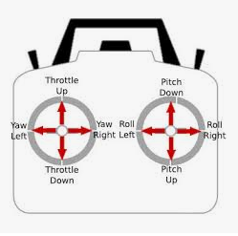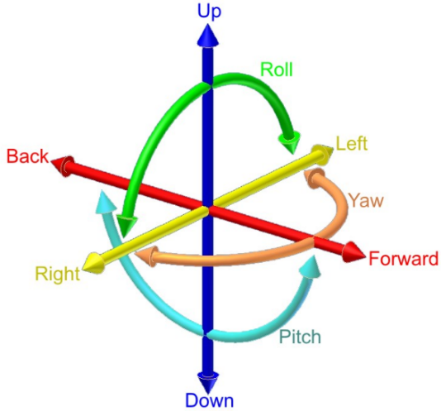 In general, users have to learn how to use the controller and they have to memorize all the functions before they try to fly the copter. This is a hard process, especially for beginners. Every flight action of a quadcopter requires the perfect fit of two hands. The traditional remote controller uses two joysticks that could move in four different directions respectively. Normally, one stick controls the throttle and yaw whilst the other controls the pitch and roll. That’s why it is complex.

**Figure 3: Throttle, pitch, yaw, a roll of quadcopter flight**

**Figure 4: How to fly a quadcopter**

Quadcopters are popular because they have big advantages over fixed-wing aircraft and the traditional helicopter. The quadcopter is relatively small and omnidirectional which means it has much better manoeuvrability than the fixed-wing aircraft and helicopters.

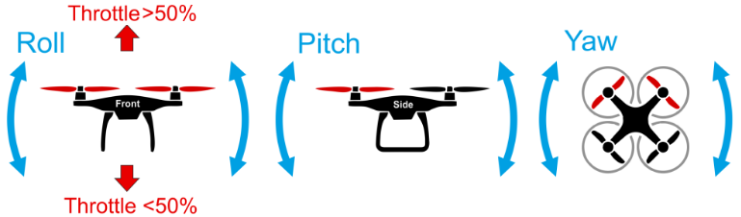 After the leap motion replaces the original complex remote controller, controlling a quadcopter will be easier and more intuitional.

**Figure 5: How to fly a quadcopter [5]**

## Section 1.3: Objective of the Project

Looking further from the aims of the project, the objective of this project can be categorised into four major categories in chronological order:

Research

* Become familiar with a microcontroller with enough knowledge to complete project
* Become familiar with C programming language and “Processing 3 IDE” software
* Become familiar with gesture sensors to choose a suitable one
* Become familiar with the control operation of Quadcopter and the functions of the handheld controller
* Understand and become familiar with microcontroller and its General-purpose Input/Output (GPIO) pins

Hardware Design and Development

* Choose a gesture/motion sensor and do a test through example programs of the sensor driver.
* Select a suitable microcontroller
* Interfacing the sensor with PC and the microcontroller
* Choose digital potentiometers/Special drive integrated circuit and design a method to drive the handheld remote-control unit.
* Design the circuit to make the whole system have a stable power supply
* Integrate gesture recognition and quad controller into a single system
* Simulating gesture recognition and control

Software Development

* Develop codes for the microcontroller to control circuits
* Develop codes for gesture sensor (include test codes)
* Develop codes to transmit the signals to make the functions of microcontroller and gesture sensor are combined

Whole system evaluation

* Evaluate and test the system’s software and hardware as a whole
* Make sure the system can at least precisely control the throttle of the quadcopter

# Chapter 2: Components selection

* **Expected components**

|  |  |
| --- | --- |
| 1 | Gesture sensor |
| 2 | 4+ Channel DSM2 Transmitter |
| 3 | Blade BLH8680G Quadcopter |
| 4 | Microcontroller |
| 5 | Potentiometers |
| 6 | SG90 servo motor/5v torque motor |
| 7 | Drive integrated circuit |
| 8 | Power supply |

## Section 2.1: Gesture sensor

During this project, the Leap motion, a hand gesture sensor, will be used as a remote controller.

Leap Motion is a device that detects and tracks hands, fingers and finger-like tools. The device operates in a relatively close environment with high accuracy and high tracking frame rate.

The Leap Motion field of view is an inverted pyramid centred above the device. The effective range of Leap Motion detection is about 25 mm to 600 mm (1 inch to 2 feet).

Leap Motion can effectively analyze the objects observed in its field of view. It can distinguish between hands, fingers and tools; provide a series of actions and position information; it can identify four specific actions: Circle, Swipe, Key Taps, Screen Taps; by continuously tracking the action flow, Leap Motion can Action in a region are understood as three basic elements: scaling, translation, and rotation.

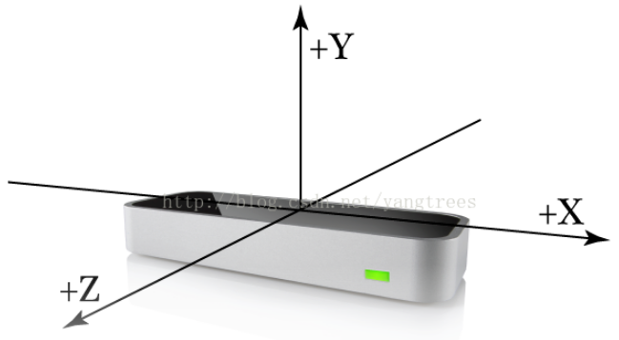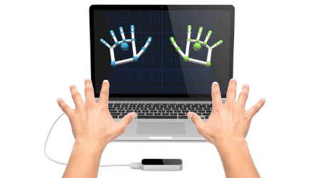Leap Motion can effectively analyze the objects observed in its field of view. It can distinguish between hands, fingers and tools; provide a series of actions and position information; it can identify four specific actions: Circle, Swipe, Key Taps, Screen Taps; by continuously tracking the action flow, Leap Motion can Action in a region are understood as three basic elements: scaling, translation, and rotation.

**Figure 2.1 Leap motion** <https://blog.csdn.net/weixin_33853794/article/details/86047996>

Advantages:

1. Easy to be connected and programmed, the leap can be connected directly to the computer by using a USB.
2. LEAP can quickly and accurately identify the position and movement of the user's hands and fingers, even for very subtle movements.
3. LEAP has a long recognition distance and is not easy to get out of control when controlling a quadcopter.
4. Low price.

Therefore, the leap motion gesture sensor was chosen to achieve the task in this project

## Section 2.2: Quadcopter and Transmitter

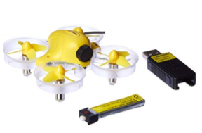Inductrix blade small copter **Parameters:**

Required: 4+ channel DSM2/DSMX transmitter

Product Dimensions: 26.9 x 20.8 x 8.6 cm ; 18.1 g

Boxed-product Weight: 612 g

Batteries 1 Lithium Polymer batteries required.

Item model number: BLH8700

ASIN: B011UDQYSC

Figure 2.2: Blade Inductrix FPV Ultra Micro Quadcopter Drone

Reason for choice:

* With the Blade® Inductrix ™ quadcopter, users can fly with little effort. Exclusive Horizon Hobby SAFE® technology combines small pitch and roll angle limits with electronic self-levelling to help users stay in control and have more fun.
* Each cylindrical rotor housing that ducts air through the high-speed rotors provides an inherently durable structure. Users can bump the Inductrix drone into practically anything with little risk.
* Brilliant LED lights are located to provide instant orientation reference. The clear rotor housings keep your view unobstructed and add an unmistakable glow to the airframe.

Therefore, the Inductrix blade small copter was chosen to achieve the task in this project as it is small, safe and easy to use.

Dx8 transmitter

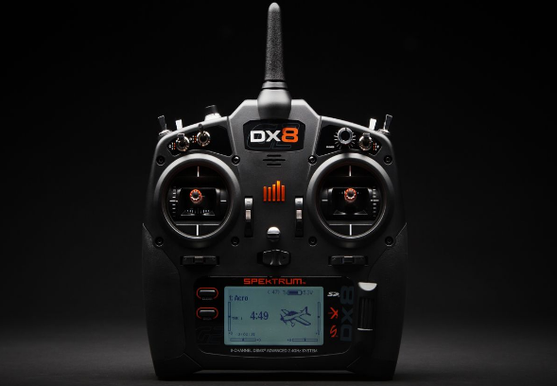

Figure 2: DX8 8-Channel DSMX Transmitter

Dx8 transmitter is an 8-Channel DSMX Transmitter which is able to band with the Blade® Inductrix ™ quadcopter, and this transmitter is strong for transmitting and receiving signals. This transmitter also has a Powerful control function. The band speed of the transmitter and Blade® Inductrix ™ quadcopter is very fast, less than 1 min.

The only drawback is that it is expensive.

## Section 2.3: Microcontroller choose

Figure 5: orange pip kona328

The Orange PIP Kona 328 development board centres around the ATmega328 microcontroller and comes with full Arduino ™ UNO compatibility.

Advantages:

* It is cheap.
* It comes with an open supply hardware feature that permits users to develop their kit.
* The software of the Arduino is well-suited with all kinds of in operation systems like Linux, Windows, and Macintosh, etc.
* Easy to learn for beginners: The programming environment is easy for beginners to use, but flexible enough for advanced users to use. Another big advantage of Arduino is the sample library included in the Arduino IDE software.
* Its biggest advantage is that we connect the board to the computer via a USB cable which does a dual purpose of supplying power and acting as a Serial port to interface the Arduino and the computer. It can also be powered by a 9V-12V AC to DC adapter.

Thus, the orange pip kona328(Arduino UNO) was chosen to control the circuit and play a role to transmit and receive the signals from leap motion.

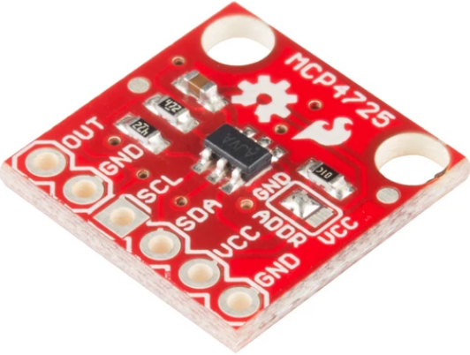**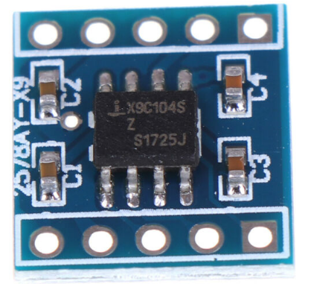S**ection 2.4 Potentiometers selection

**Figure 2.4 the digital potentiometer x9c104 and mcp4725**

A digital potentiometer (also called a resistive digital-to-analogue converter, or informally a digipot) is a digitally-controlled electronic component that mimics the analogue functions of a potentiometer. It is often used for trimming and scaling analogue signals by microcontrollers.

• It is referred to as mixed-signal device as it enables digital control of a variable voltage.

• It is an IC chip which emulates the function of the analog potentiometer.

• It is digitally programmable as its internal resistance can be varied using input control. Hence it is used in conjunction with the microcontroller to control internal resistance of the component.

Reason for choice:

* It is smaller in size and hence can be placed very close to other chips on the board. Wide range of resolution
* Much more writing cycles than mechanical parts
* It offers a digital interface
* It can be programmed

The application of the digital potentiometer would be introduced in Chapter 3, the x9c104 digital potentiometer is a key component for Project design concept 2.

[https://www.rfwireless-world.com/Terminology/Advantages-and-Disadvantages-of-Digital-Potentiometer-over-Analog-Potentiometer.html ]

## Section 2.5 SG90 servo motor/5v torque motor choose

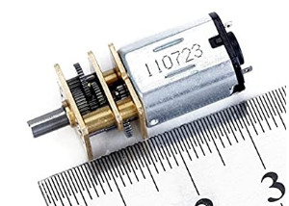

**Figure 2.5 3v-6v torque motor**

Voltage range: 3V-6V DC. No-load rotating speed: 40 ±10%RPM. Ambient temperature: -5°C - 40°C.

Load torque: 0.5kg. cm. Load current: 0.06A (0.09A Max.). Load rotation: 31.4 ±10% RPM.

Rotor current: 0.29A. Rotor torque: 2.3kg. cm.

Axial play: 0.3mm or less. Motor idle current: 0.030A. Motor idle rotation speed: 11500±10 %RPM.

Reason for choice:

Small, easy to be placed and have enough torque to be used in project design concept 1.

The application for this component would be discussed in Chapter 3.

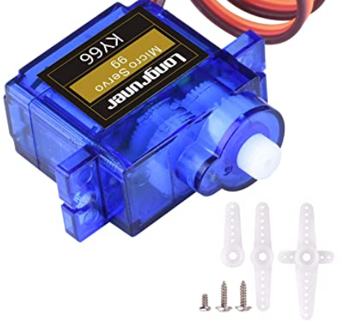 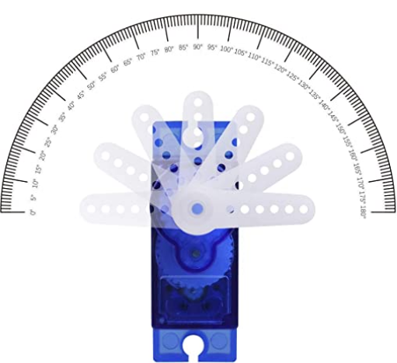

**Figure 2.51 SG90 servo motor**

**Parameters:**

Operating speed: 0.12second/ 60degree (4.8V no load)

Stall Torque (4.8V): 17.5oz /in (1kg/cm)

Operating voltage: 3.0V~7.2V

Temperature range: -30 to +60

Dead band width: 7usec

Reason for choice:

* Small
* Easier to be programmed
* The rotation degree can be controlled
* Hight accuracy
* The circuit is also easier to be constructed.

The application for this component would be discussed in Chapter 3.

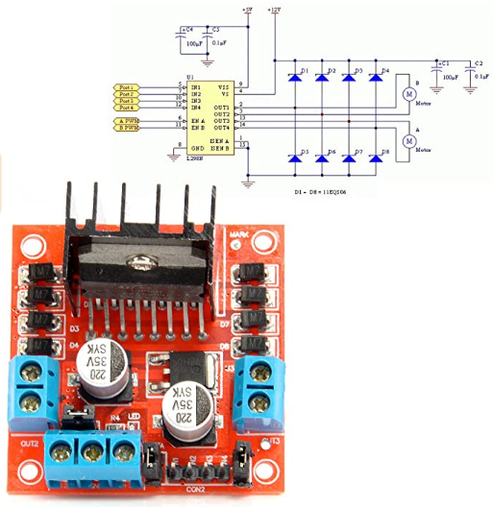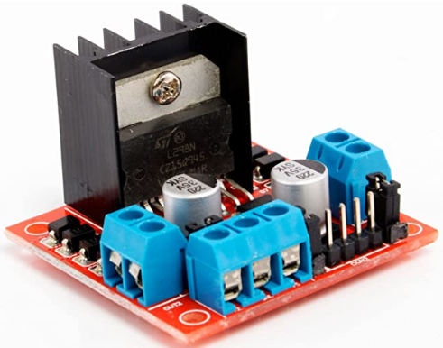**S**ection 2.6 Drive integrated circuit

**Figure 2.6 L298N DC stepper motor controller drive**

**Feature:**

1. The output pins have connections with tongs and OUT1, OUT2 and OUT3 of the first motor, OUT4 marked for the second motor
2. Ensure sufficient voltage and current for your engine at pins VCC and GND
3. This module integrated with one internal 5V power supply, meaning when the driving voltage is 7V-35V, it makes 5V of energy board power supply logically; when 5V of energy board power on, please not input voltage to +5V power supply in the interface but you can lead 5V voltage for external usage
4. Built-78M05, the drive power receiving power, but when the drive power exceeds 12V, use the power of 5V external power

Reason for choice

* L298N as main driver chip makes strong driving ability, low heating, strong anti-interference
* The module is driven by Dual-channel H-bridge, it can drive two motors simultaneously that creates higher working efficiency
* The speed and direction can be easily controlled using Arduino
* Large-capacity filter capacitors and diode with freewheeling protection function, increasing reliability
* This module can use built-in 78M05 for electric work via a driving power supply part
* It can be used to control the motor mentioned in figure 2.5
* It can be used to provide a constant power supply

The specific application for this component would be discussed in Chapter 3.

## Section 2.7 Power supply

In order to make the whole system run stably, a battery pack is considered as a power supply.

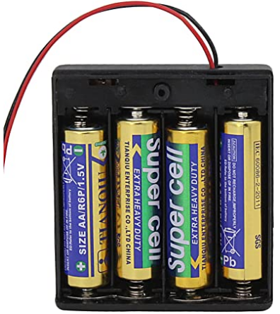

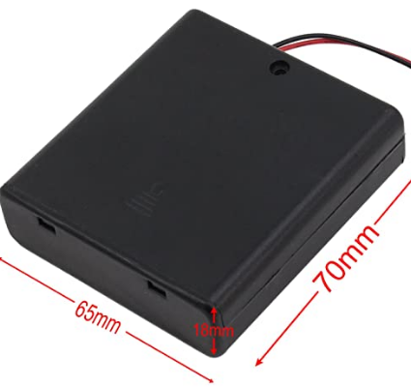**Figure 2.7 6v battery pack**

**Reason for choice:**

* High-quality battery holder case with wire leads for easy soldering and connecting.
* Battery Type: 4x 1.5V AA battery；Battery Cable : 15cm;Material: Durable plastic and metal.
* Each battery holder comes with a case cover for keeping the battery in place.
* Great items for keeping your standard or rechargeable batteries together and safe.

This component provides a stable 5v voltages for the microcontroller mentioned in Section 2.3, it has to be connected with the drive mentioned in section 2.6 first.

The specific application for this component would be discussed in Chapter 3.

# Chapter 3: Project design concept and analysis

## Section 3.1: Project design concept 1



**Figure 3.1 Project design concept 1**

In the design concept 1, the leap motion and Arduino both should be connected with PC first, then the signal should be handled and transmitted by using programming Software on PC (processing 3 and Arduino IDE), The L298N motor drive needs to be connected with Arduino, then the codes in Arduino should make the L298N be able to control the rotation of the motor, the method of the motor to control the handhold controller will be shown in Figure 3.11.

****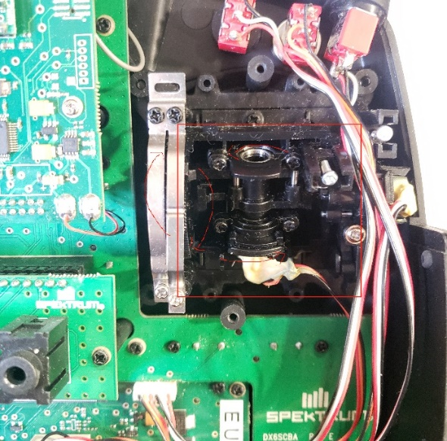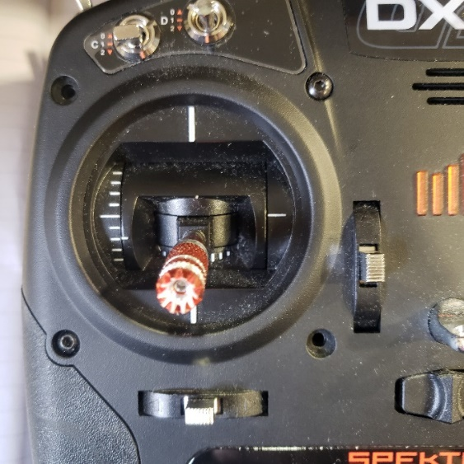**Handhold controller and its Internal structure**

**Figure 3.11 Dx8 Handhold controller**

In concept 1, the red part should be added a torque motor to pull or push the mechanical part to control the throttle, the motor should be controlled by the L298N drive which is connected to the microcontroller. The Arduino is connected to a gesture sensor. If the user’s hands move up, the motor should push the joystick up, if the user’s hand move low, the motor should pull the joystick down, Thus, the throttle can be controlled.

**Figure 3.12 control concept**

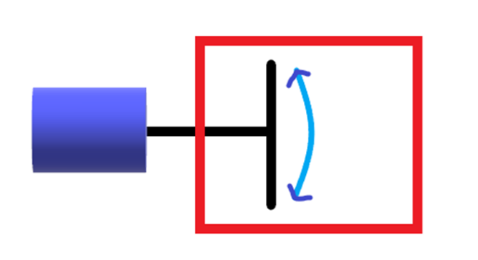

The figure showed if the hands move up, the torque motor rotates up, the throttle will be pulled high if the hands move down, the torque motor rotates down, the throttle will be pulled low.

The L298n and Arduino played the main role to control the motor.

**The detailed circuit design and specifications are shown below**

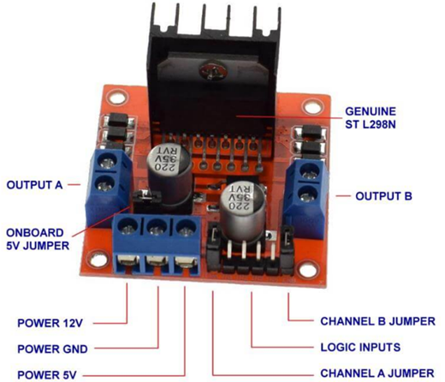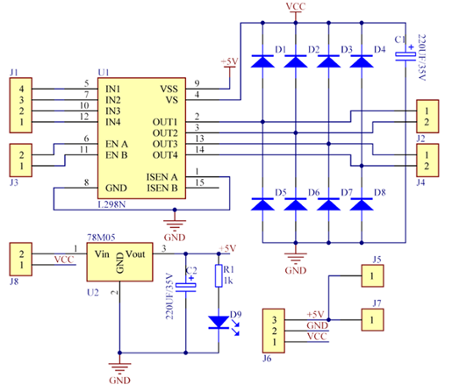**Figure 3.13 L298n stepper motor drive board and circuit**

Specifications of L298N Motor Driver

1. The module will allow users to control the speed and direction of two DC motors.
2. It can control motors that operate between 5 to 35V and up to 2A.
3. The module has an onboard regulator which helps in giving the output of 5V.
4. The module can be powered from 5 to 35V from Arduino or external power supply. It is recommended to always use the external voltage supply.
5. It can also control a stepper motor.
6. It is inexpensive and perfect for robotic projects.

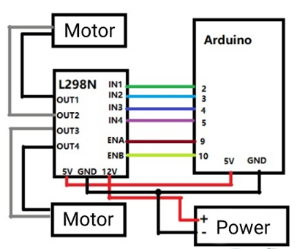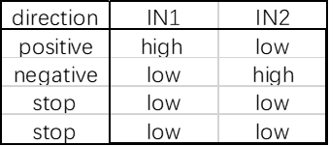In order to control the direction of rotation of the motor, L298n has to be connected to the Kona328 board (Arduino Uno).

**Figure 3.13 circuit of L298n with Arduino**

The 6V battery pack should be connected to the 12V input pin, the 5v output pin should be connected to Arduino board so the Arduino will have a constant 5v power supply. The two pins of the motor would be connected to out1/out2, the IN1/2 pins should be connected to the pins 1/2 on Arduino board for signal transmission.

Once the circuit is constructed, the Arduino should be able to control the motor rotation by correct codes.

As figure 3.13 showed, if the voltage of IN1 is high, and the voltage of IN2 is low, the Motor rotation direction would be positive. If the voltage of IN1 is low, and the voltage of IN2 is high, the Motor rotation direction would be negative. If the voltages are the same in IN1 and IN2, the motor will stop rotating.

**Example codes**

void loop() {

//forward

digitalWrite(input1,HIGH); //high

digitalWrite(input2,LOW); //low

delay(3000); //time

}

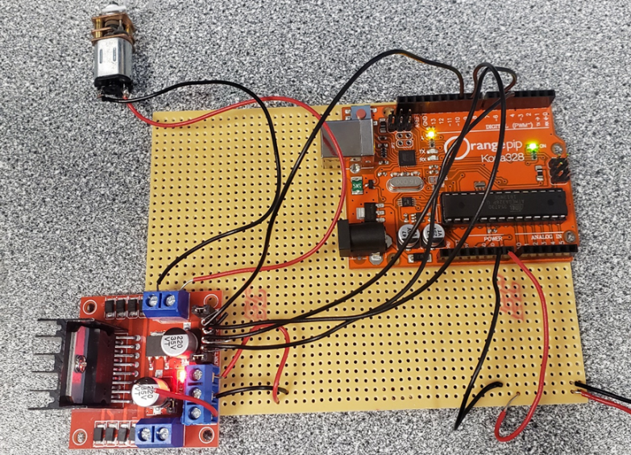As shown in the example codes, IN1 and IN2 are defined as input1 and input2, delay(3000) means the motor will rotate positive for 3000ms.

**Figure 3.14 Basic torque motor circuit on stripboard**

Firstly, the system operation needs to be tested without leap motion connecting to make sure the motor is able to control the throttle smoothly and accurately if the signal transmission between the leap motion and Arduino is done, but the motor can not pull or push the joystick on handhold controller properly, it will waste a lot of time and budget.

The torque motor is fixed on the handhold controller, iron wire is used to connect the motor rod with the joystick.

|  |  |
| --- | --- |
| Advantages | Disadvantages |
| 1. Have enough torque to pull and push the joystick on handhold controller. 2. Small, easy to be fixed on the handhold controller 3. Can be fixed on the outside of the handhold controller, no need to open up the expensive DX8 controller. | 1. There is no suitable gear for the torque motor, the wire wound on it is easy to slip.  2. The surface of the motor is metal which is hard to be fixed on the plastic case of the DX8 controller.  3. Although the rotation speed of the torque motor is already very slow, it is still too fast for the joystick.  4. The rotation angle cannot be controlled, the throttle can only be pushed to the largest or smallest, which is dangerous for the Quadcopter. |

## Section 3.2: Project design concept 2



In the design concept 2, the leap motion and Arduino both should be connected with PC first, then the signal should be handled and transmitted by using programming Software on PC (processing 3 and Arduino IDE), the Digital potentiometers circuit need to be designed and connected to Arduino, the digital potentiometers also need to be connected to handhold controller by modifying the wires inside the DX8 controller, therefore the joysticks now are replaced by voltage signals from the digital potentiometer, and the voltages signal would be able to send the control command to the Quadcopter.

A digital potentiometer (also called a resistive digital-to-analogue converter, or informally a digipot) is a digitally-controlled electronic component that mimics the analogue functions of a potentiometer. It is often used for trimming and scaling analogue signals by microcontrollers. So the Digital potentiometers here is to simulate joystick signal and transmit it to the quadcopter. For the potentiometers, digital potentiometers will be used in this project. Digital potentiometers are a new type of CMOS digital alternative to traditional mechanical potentiometers (analogue potentiometers) that simulate mixed-signal processing integrated circuits. The digital potentiometer is controlled by a digital input to generate an analogue-digital potentiometer. The numerical value is used to adjust the resistance value. It has flexible, high precision and non-polar output. Output. Depending on the digital potentiometer, the tap current can be shorted from a few hundred microamps to a few milliamps. low noise, not easy to foul, anti-vibration, anti-interference, it has a small size, long life and other significant advantages can replace mechanical potentiometers in many fields.

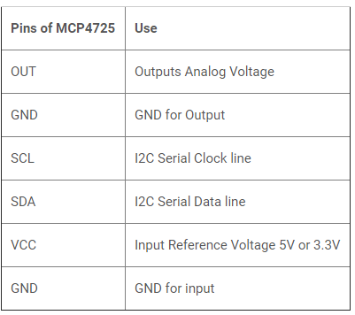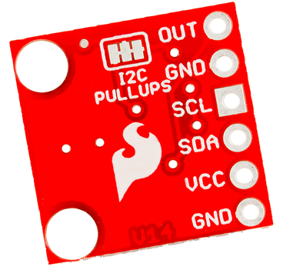

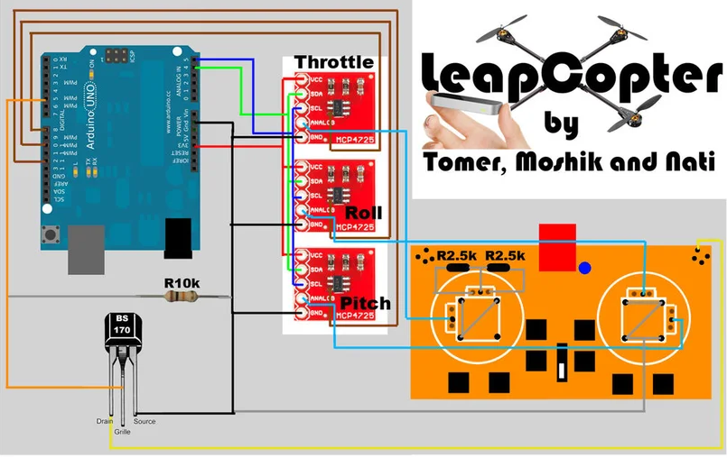**Figure 3.21 digital potentiometer MCP4725**

**Figure 3.22 example circuit of the whole system**

1. Connect the VCC output from each of the 3 A/Ds (analogue-to-digital converter) together to the Arduino's 3V3 input (The RED wires on the circuit picture)

2. Connect the SDA output from each of the 3 A/Ds together to the Arduino's analogue 4 input (The GREEN wires on the circuit picture)

3. Connect the CSL output from each of the 3 A/Ds together to the Arduino's analogue 5 input (The BLUE wires on the circuit picture)

4. Connect the ANALOG output from each of the 3 A/Ds and choose one for the throttle, one for the roll, and one for

the pitch. (The light blue wires on the circuit picture)

5. Connect the GND output from each of the 3 A/Ds together to the Arduino's GND input (The BLACK wires on the circuit picture)

6. Connect a wire to the lower-left pin in each of the main chips in the 3 A/Ds and using a magnifying glass:

in the throttle, A/D connect the wire to the Arduino's digital 8 (The brown wires on the circuit picture)

in the roll A/D connect the wire to the Arduino's digital 10 (The brown wires on the circuit picture)

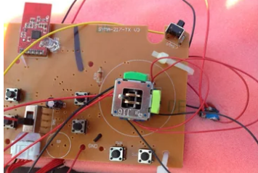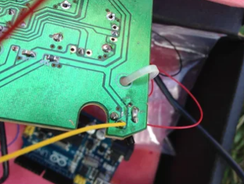 in the pitch, A/D connect the wire to the Arduino's digital 12 (The brown wires on the circuit picture)

**Figure 3.23 motherboard of the handhold controller**

As the picture shown, the original wires need to be modified to connected to the potentiometer circuit.

|  |  |
| --- | --- |
| Advantages | Risks and disadvantages |
| 1. high control accuracy  2. Fast response speed  3. Take up less space | 1. The more complex circuit structure  2. Difficult conceptual understanding  3. Easy to damage an expensive controller, once the controller is broken, the entire project cannot continue constructing.  4. The internal circuit of the controller is complicated, there is very low fault tolerance.  5. expensive, many of the Mcp4725 are broken |

## Section 3.3: Project design concept 3



In the design concept 3, the leap motion and Arduino both should be connected with PC first, then the signal should be handled and transmitted by using programming Software on PC (processing 3 and Arduino IDE). The SG90 servo motor does not need L298n motor drive, so the L298N motor drive here is used as a Voltage stabilizer, the power supply is a 6V battery pack, therefore the L298N component is on duty to provide a constant 5V voltage to Arduino board. The SG90 servo motor needs to be connected with Arduino, then the codes in Arduino should be able to control the rotation of the SG90 servo 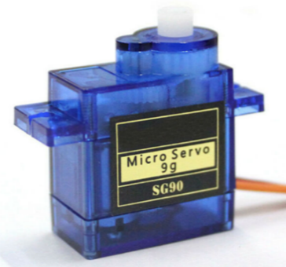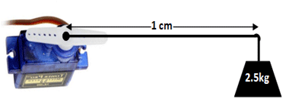motor, the method of the motor to control the handheld controller can be shown in Figure 3.11 and 3.12. which is very similar to design concept 1.

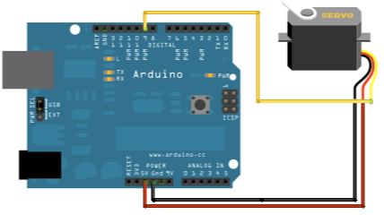**Figure 3.31 SG90 servo motor**

**Figure 3.32 Example circuit**

Firstly, the system operation needs to be tested without leap motion connecting to make sure the SG90 motor is able to control the throttle smoothly and accurately if the signal transmission between the leap motion and Arduino is done, but the motor can not pull or push the joystick on handhold controller properly, it will waste a lot of time and budget.

The SG90 servo motor is fixed on the handhold controller, original gear is used to connect the motor rod with the joystick.

|  |  |
| --- | --- |
| Advantages | Disadvantages |
| 1. Have enough torque to pull and push the joystick on handhold controller. 2. The plastic shell is easy to be fixed on the handhold controller 3. Can be fixed on the outside of the handhold controller, no need to open up the expensive DX8 controller. 4. High accuracy and fast response speed, the rotation degree can almost follow the height of the user’s hand. 5. Simple circuit and concept required. 6. Cheap and fewer components required | 1. Need at least four to achieve full functions, they would need a large space to be fixed. |

## Section 3.4 Project design concept analysis

After comparison,

The project design concept 3 shows a better performance, it doesn’t need to cut wires in the transmitter, therefore it won’t damage the expensive transmitter, it is easier to construct, combined mechanical components and embedded programming. It is also easier to program. This concept almost includes both advantages of concept 1 and concept 2 and only has a not serious shortcoming. Thus, concept 3 would be chosen as a final implementation plan, all the detailed work could be seen in Chapter 4.

# Chapter 4: Project design concept 3 implementation

## Section 4.1: Hardware design

As section 3.3 mentioned, the SG90 servo motor would play a significant role to control the flight of quadcopter. Firstly the circuit of the Arduino, L298n, SG90 motor needs to be designed and constructed, only a USB power supply on Arduino is not enough for SG90 motor, so the battery pack mentioned in Section 2.7 would also be connected to the main circuit, The circuits can be shown below.

[**https://lastminuteengineers.com/l298n-dc-stepper-driver-arduino-tutorial/**](https://lastminuteengineers.com/l298n-dc-stepper-driver-arduino-tutorial/)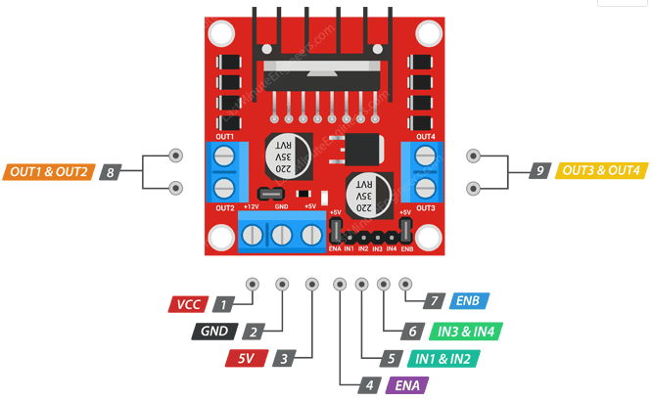

**Figure 4.11 L298N circuit**

In concept 3, the L298N component is only used as a voltage stabilizer, because the rotation of SG90 motor can be directly controlled by Arduino, so only the VCC, GND, 5V pins are needed to provide a constant 5V power to Arduino.

VCC pin supplies power for the board. It can be anywhere between 5 to 35V.

GND is a common ground pin.

5V pin supplies power for the switching logic circuitry inside the L298N IC. If the 5V-EN jumper is in place, this pin acts as output and can be used to power up your Arduino. If the 5V-EN jumper is removed, you need to connect it to the 5V pin on Arduino.

The battery pack mentioned in section 2.7 provides a 6V voltage, the red wire(positive) of the battery pack should be connected to the VCC pin on L298N, the black wire and GND pin should be connected to the ground. The 5V pin on L298N should be connected to the 5V pin on Arduino.

**Figure 4.12 Power supply to Arduino**

After the circuit constructed, the Arduino now should have a stable 5V power supply, no matter how large the voltage provided by battery pack is, the power supply will always be 5V, which meet the required voltage limit for SG90 servo motor.

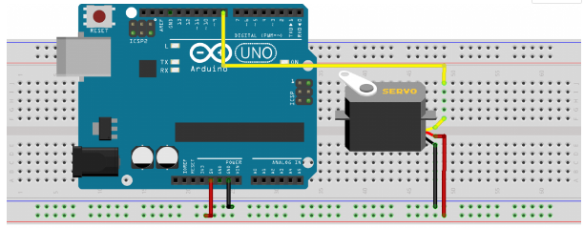Then the SG90 servo should be connected to Arduino.

**Figure 4.13 SG90 connection with Arduino**

As the Figure is shown, the circuit for connection between the SG90 servo motor and Arduino is quite easy.

Servo motors generally have three pins/wires, this includes the VCC, GND, and the Signal pin. The Signal pin is the one used to feed the control signal from the microcontroller to the servo, to get the servo to rotate to a particular angle. The yellow wire in figure 4.13 is the signal transmission wire, it could be connected to any digital pin on Arduino because it is a PWM pin (Pulse width modulation is a powerful technique for controlling analogue circuits with a microprocessor's digital outputs. PWM is employed in a wide variety of applications, ranging from measurement and communications to power control and conversion.). Servo directions are sent from the microcontroller to the servo motor as PWM pulses.

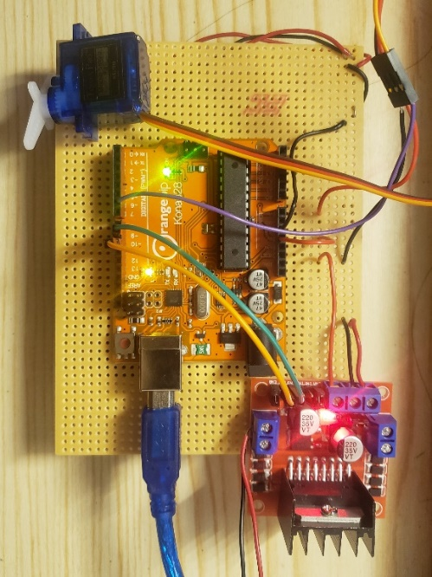With the connection all done, the test codes should be written to test the working status of SG90 servo motor, this process could be seen in Section 5.1.

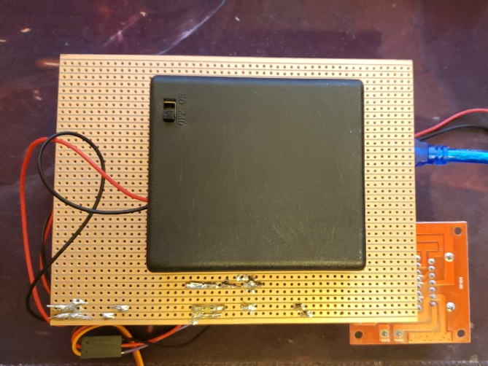The whole circuit now is shown below

**Figure 4.14 whole circuit of SG90-Arduino-L298N**

# Chapter 5: Software design

The software design is the most important part in the whole project, the signals from the leap motion must be transmitted to Arduino through PC, in this way, users’ hand gesture could control the rotation of SG90 servo motor, otherwise, the hardware part would be useless.

## Section 5.1: SG90 servo motor test

<https://www.electronics-lab.com/project/using-sg90-servo-motor-arduino/>

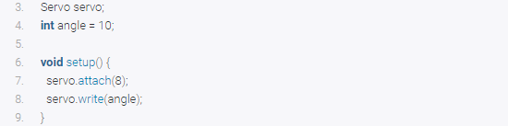The code for testing is quite simple thanks to the servo.h library developed by the Arduino team to facilitate the use of servo motors in Arduino projects. The library makes it easy to turn the servo at different angles using a single command. The library comes pre-installed in the Arduino IDE removing the need for users to download and install.

The example codes are shown below, Figure 5.11 and Figure 5.12

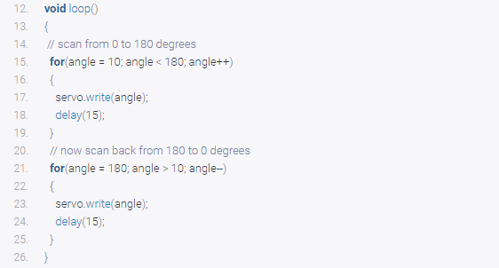This part defined the digital pin 8 as the signal pin and turned the rotation degree to 10.

In the loop, the code means, servo motor rotates from degree 10 to 180, after 15ms delay, the servo motor rotates back to 10.

This code is for testing whether the SG90 servo motor circuit is working or not, if it is working, the servo motor should start turning as above illustrated.

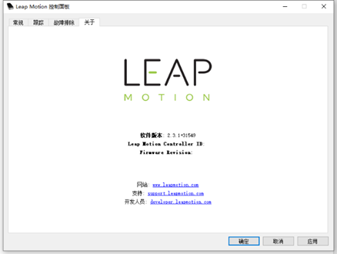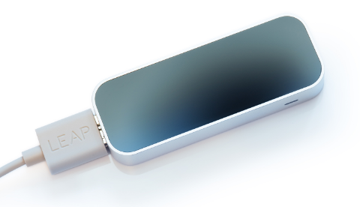**S**ection 5.2: leap motion test

**Figure 5.21 leap motion and drive.**

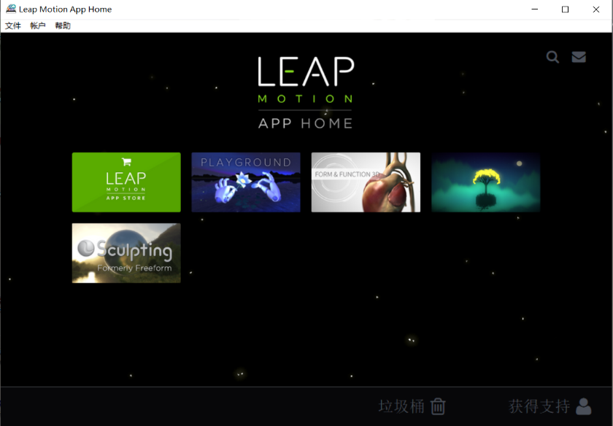**Figure 5.22 Leap motion APP home**

Firstly, the drive for leap motion needs to be download from the official website. After downloading, two software called “Leap Motion control panel” and “Leap Motion App home” should be able to find on the desktop. There is already some software in “Leap Motion App home”, users can use the software to test the leap Motion is working or not. At the first time the software may not run properly, the general solution is:

Go to the directory of the leap motion, find a File named "LeapSvc64", click to install it as a 64-bit version.

## Section 5.3: “Processing 3” IDE with Leap Motion

**Figure 5.31 Processing 3 IDE**

Processing is a flexible software sketchbook and a language for learning how to code within the context of the visual arts. Since 2001, Processing has promoted software literacy within the visual arts and visual literacy within technology.

Free to download and open source

Interactive programs with 2D, 3D or PDF output

OpenGL integration for accelerated 2D and 3D

For GNU/Linux, Mac OS X, and Windows

<https://www.dcu.ie/iss/software/Processing-P3.shtml>

Processing 3 here is for handling the signal from leap motion on PC, then transmitted the signal to Arduino board. C programming language would be used to develop the code.

Communications between Arduino and leap motion can be simply shown below.

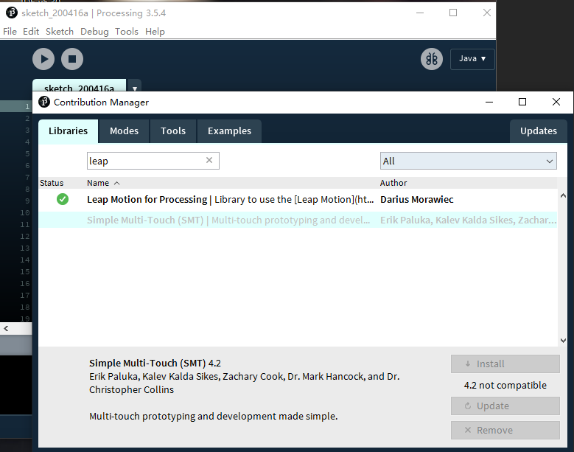**Figure 5.31 Leap Motion library in processing 3**

For processing 3, there is already an example code for testing the connection between the Processing 3 IDE and Leap motion, firstly the library needs to be added, then the code can be found in Example codes.

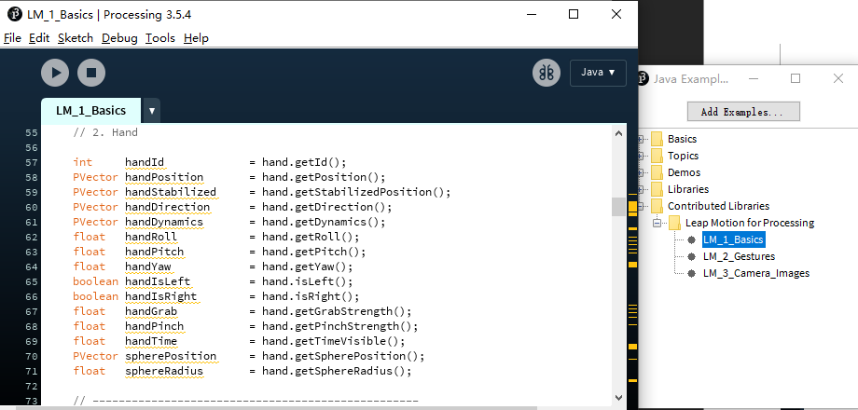

**Figure 5.32 Leap Motion library in processing 3**

As shown in Figure 5.32, LM_1_Basics provides the example code for testing the Leap Motion, there are also lots of useful codes for learning to develop the code later.

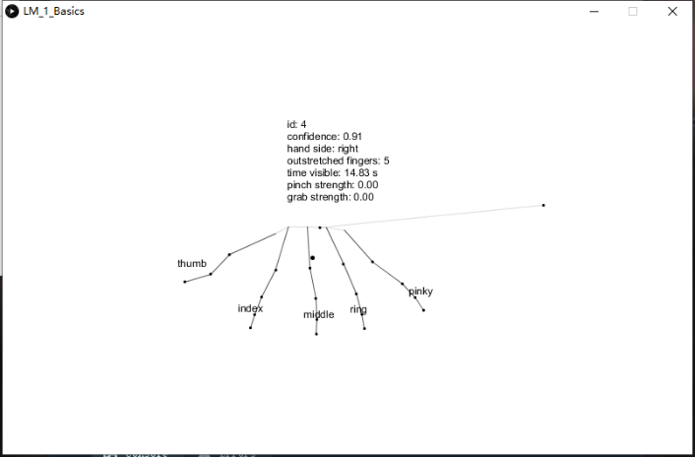Connected the Leap Motion to PC, then compile and run the example code.

**Figure 5.33 The example gesture recognition program**

As shown in Figure 5.33, if the leap motion and the codes are working properly, the structure of hand would appear in the window.

The coordinates of the hands are also shown in the window, the structure of hand in the window will change with the movement of users’ hand at the same time. Leap Motion can detect all fingers, wrist angles, palm, pitch, yaw, roll and waving of hands these all the process that can be used for controlling servo motors with a leap motion controller with Arduino. With the help of the cameras motion detector sensor captures the images and process them to see which gesture exactly moves. It can only work if gestures moving in a limit. Limit of motion control sensor is from 1 inch to 2*2 feet.

After all the test parts are done, the communication between the leap motion and Arduino board is ready to start, the code for leap motion will be developed on Processing 3 first, the process would be shown in Section 5.4.

## Section 5.4: Communication code

In this section, the codes for Leap motion (Processing 3) and SG90 servo motor (Arduino) would be developed.

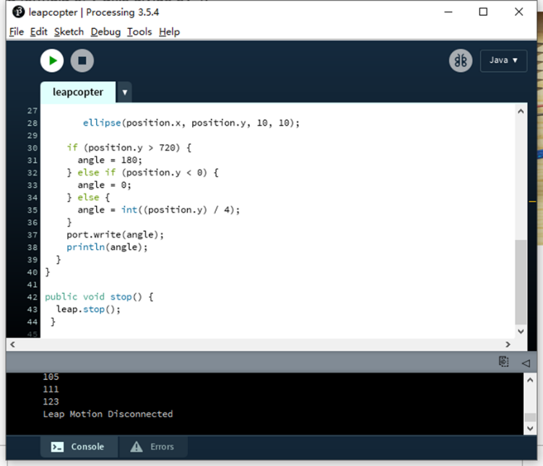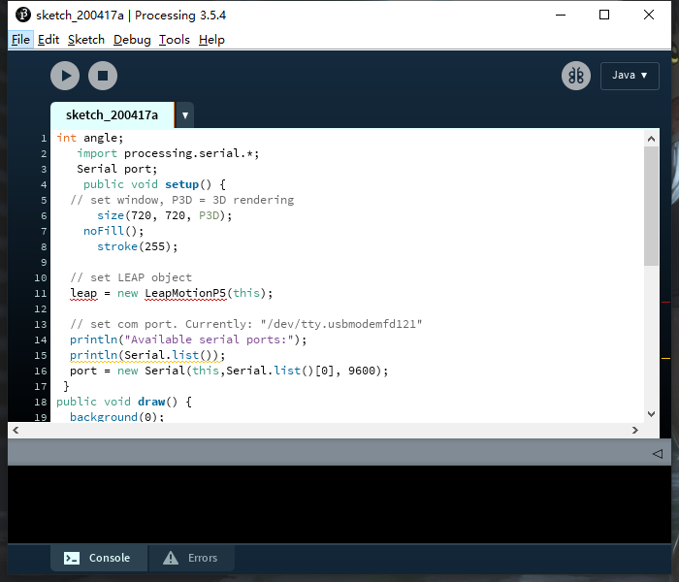Firstly, the leap motion and Arduino need to be connected to the same PC by USB cables.

**Figure 5.41 The example code on processing 3**

For this part

Creating a class of leap and making an integer of name angle which is used further for storing the angles of the servo motor and transmitting it to Arduino. The code” import processing.serial.*;” used to communicate the processing software commands and sends it to Arduino via the serial port. At detection of gestures in motion sensor along Y-AXIS the particular value assigned to servo motor via leap motion controller then processing and Arduino interchanged the value with each other by serial-communication.

In setup when running the program in processing new windows open. The size of the new window is 720*720. In these windows, 5 fingers dots could be shown. If users wave their hand gestures after recognizing the movements of gestures their gestures shown in that window.

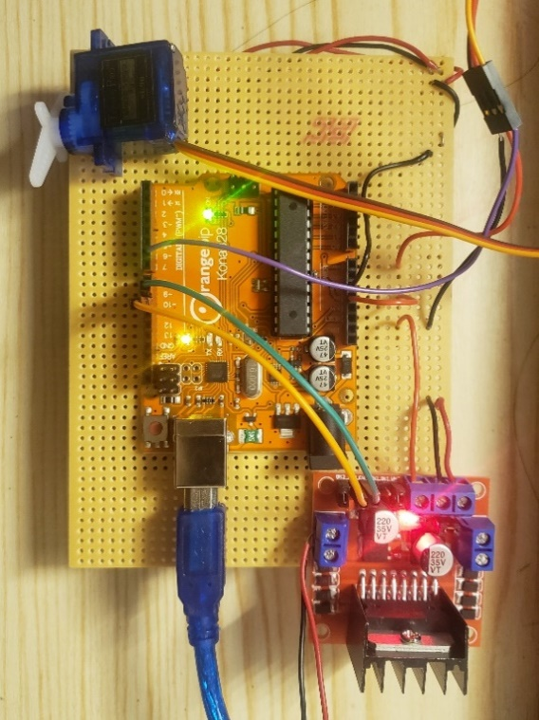As mention above when users run the program, a new window open which is 720 height and width. This window is used for controlling the position of the servo with 3D hand recognition technology. If hands above the 720 size the servo angle move to 180 degrees. If the position of hand gestures is below the zero the angle turns to 0 degrees. In between the windows, the angle has a formula of the y-axis divide by 4.

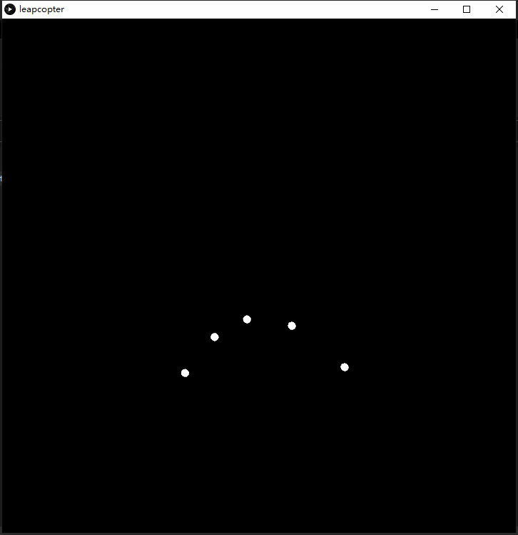

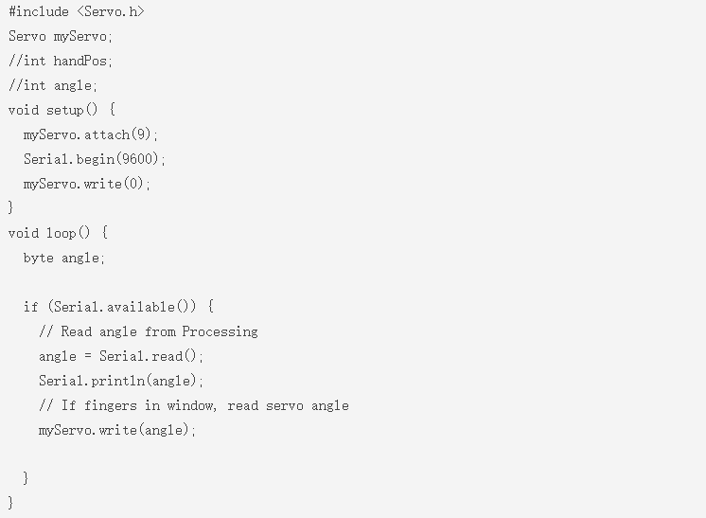**Figure 5.42 processing 3 window and servo circuit**

**Figure 5.41 The example code on processing 3**

In setup attach the signal wire of servo motor is connected to Pin 9, Communicate serially with serial. begin command with the baud rate of 9600. Baud rate can also be changed if needed.

Read serial if available means read the angle from processing or whatever values coming from processing via hand detection. Saved in variable named angle and write it to the servo motor. Remember that values are within 0 to 720 range. whatever gestures come to leap motion controller the processing tracks and send data to Arduino that moved servo motor at some special angles.

One thing is important, the processing 3 IDE and Arduino IDE must be opened at the same time, if only one of them is activated, the signals can not be transmitted due to no transmitter/receiver.

Once the codes compile successfully, the system should be able to use the leap-motion to control the rotation of the SG90 servo motor properly.

# Chapter 6: system evaluation

In this chapter, the development of hardware and software will be combined into a single system. The whole system is built on a single stripboard, which is easy to connect and use. The result of the whole system and its problems will be discussed.

## Section 6.1 System mechanism

At the beginning of the project development, the system mechanics or the design of how the whole system is going to work out as planned. The planning was aimed to get an overview of how the whole system is going to work. Concerns for the project were addressed, including the software's flow, how the locking mechanics work and the ability to identify the hand gesture and control the rotation of SG90 motor.

The system's mechanic is designed to work according to the following steps:

1. Detect hand gestures from the Leap Motion.
2. If gestures are detected, the coordinates of fingers will be read by processing 3 IDE, the structure of hands will be displayed on the window on PC.
3. If the hand is high, the signal (make the servo motor rotates from 0 -180 degree) will be sent to Arduino board. If the hand is low, the signal (make the servo motor rotates from 180 - 0 degree) will be sent to Arduino board.
4. The Arduino will receive the signals then send the rotation signal to the SG90 servo motor.
5. The SG90 motor starts to rotate, which will pull or push the throttle joystick on the handheld controller to low or high.
6. The Quadcopter then will fly high or low.

**Figure 6.11 Flowchart of the Throttle control**

**The flow chart shows how the throttle controlled by the Leap Motion gesture sensor.**

## Section 6.2 Integration of SG90 board with a handheld controller

Since the signal transmission part was completed, the leap motion can control the rotation of the SG90 servo motor. Then only the mechanical part between the gear of SG90 servo motor and the joystick of the handheld controller need to be designed and constructed. Fortunately, this process is not difficult because there are many methods to connect them, however, which method is the most efficient still need to be considered.

Firstly, the three methods are considered and tested.

1. 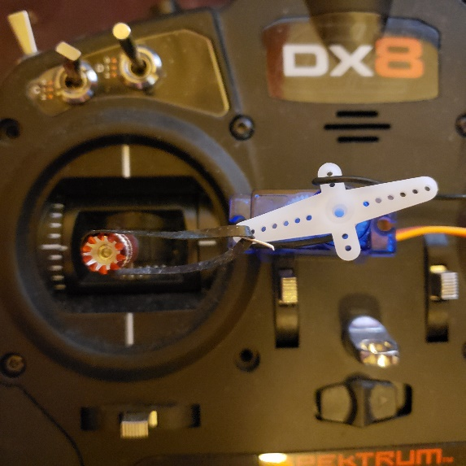Use Rubberband between the SG90 motor gear and the joystick of the handheld controller.

**Figure 6.21 Rubber band**

With this method, the SG90 servo motor could pull the joystick to high and low, however, there is always a delay between the gear and joystick. And the effective push-pull distance

Is too short, the joystick can only move a little.

This method may also cause the quadcopter rotates left or right.

1. Use iron wire between the SG90 motor gear and the joystick of a handheld controller.

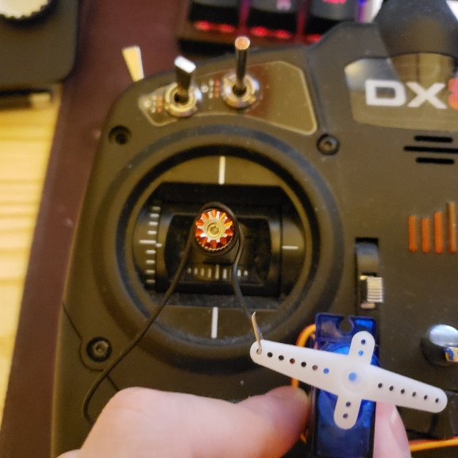**Figure 6.22 Iron wire**

The position of the SG90 servo motor should be placed lower, method 2 is an improvement measure for method 1.

With this method, there is no delay between the gear and the joystick of the handheld controller because the iron wire provides a hard connection.

The effective push-pull distance can be modified to long or short by modifying the length of iron wire between the gear and joystick, therefore the throttle control limit can be modified to large or small.

With this method, if the throttle reaches the largest limit, it will be pulled from high to low, this could be regarded as an advantage.

1. Use iron wire between the SG90 motor gear and the joystick of the handheld controller.

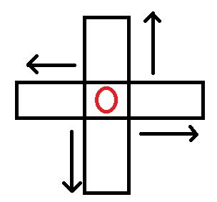**Figure 6.23 3D printer mechanical part**

As the picture shown, the red circle in the middle is the throttle joystick. The two black squares (on the Horizontal axis and Vertical axis) around the joystick are the mechanical parts which can be 3D printed.

The two squares can move up/down, left/right, to control the throttle joystick.

In theory, this method can provide a stable and effective experience, however, it hasn’t be achieved, it could be regarded as an advanced plan in future.

Method 2 is current using, the performance is not stable enough and the structure is simple and crude, there would further development for it later.

## Section 6.3 Increasing the recognize precision of processing 3 (Leap motion)

As Section 5.4 mentioned, the leap motion will recognize the hand gesture then send the signal to Processing 3 IDE. If the gesture is more complex or more fingers are used, the transmission speed would get slow, there will also have a small delay between fingers and the motor gear.

For example, if the user waves his/her whole hand on the top of leap motion, there would be a small delay, when the hand up/down, the SG90 servo motor may start to rotate after 400 ms, the delay is short, however for controlling the quadcopter, it is very dangerous because when users try to make the quadcopter fly lower it may still fly upper. Sometimes if the gesture changes too fast, the gear of SG90 servo motor may shake several times, this will also cause quadcopter unstable.

**Figure 6.31 control precision when using 1-5 fingers**



**Figure 6.32 Number of fingers used to control the quadcopter**

As the experimental data showed, when using full hand to control the quadcopter, the signal transmission might be slow, SG90 servo motor rotates unstable, therefore the quadcopter will have an unstable fly experience.

By contrast, when using 1 finger to control, the SG90 servo motor almost has a real-time response, it rotates also stable, thus, the quadcopter would fly stably and follow every instruction from users’ hand accurately. The user will also feel more relaxed when using fewer fingers to move on the top of the Leap Motion.

Thus, it is recommended that users use fewer fingers on the top of the Leap motion to control the throttle of the quadcopter.

## Section 6.4 System evaluation

In this section, the results of the final testing where the hardware and software sections are combined into a single system will be evaluated. The final system is shown in figure 6.41.

* 1. battery-powered and power plug are successful.
  2. Leap Motion recognition successful.
  3. Signal transmission successful.
  4. SG90 servo motor rotates properly.
  5. Throttle joystick moved properly.
  6. Quadcopter flew up/down successfully.

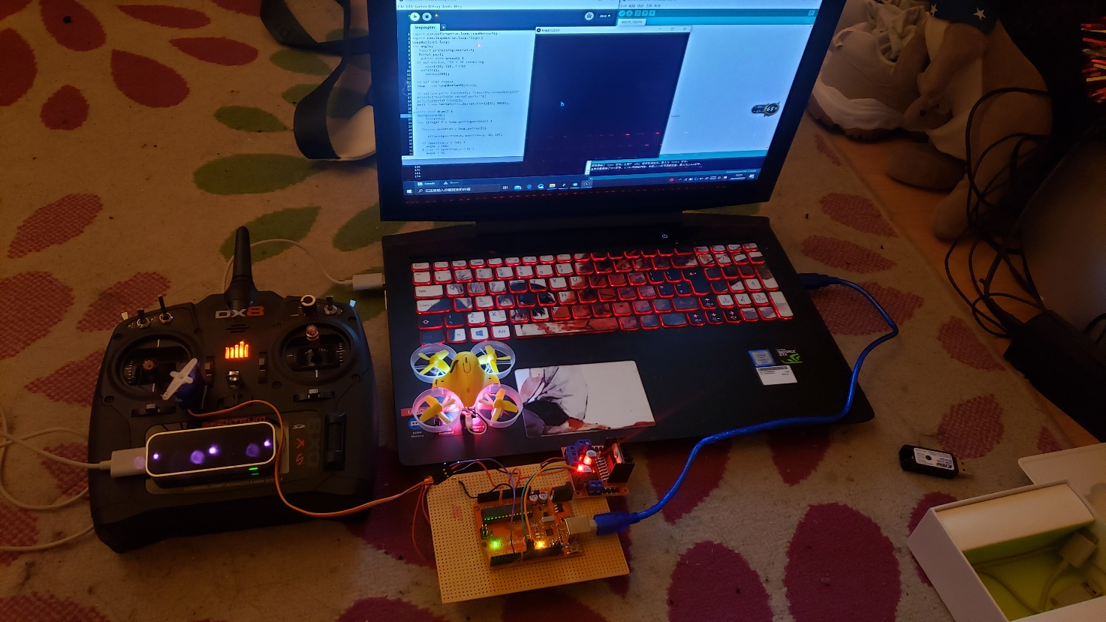

**Figure 6.41: Whole system review**

The leap motion throttle control was then tested 200 times in total to test its stability and accuracy.

The environment that was tested was in a lightroom (100 times) and in a dark room (100 times). The results can be seen in the table below.



**Table 6.42: Experimentation results in a light environment (100 times)**



**Table 6.43: Experimentation results in a dark environment (100 times)**

**Figure 6.44 Video screenshot**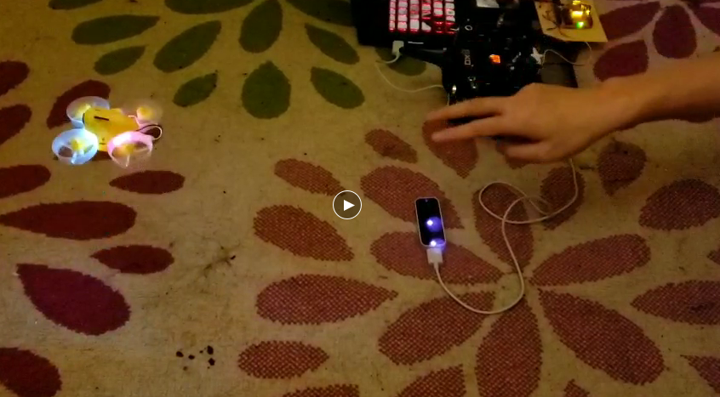

As the table shown, the Leap Motion recognition and the throttle control have very high accuracy, sometimes my hand is on the top of the leap motion by accident, that’s the reason why the up/down failed.

In the dark environment, it may recognize wrong several times, but it still has high accuracy because Leap motion is using 3 cameras.

Overall, the throttle controlled by leap motion is successful, it has high accuracy and stability in both light and dark environment.

# Chapter 7: Future Work



**Appendix: Supervisor Project Description**

“Hands-free" control of a Quadcopter

A quadcopter is a multi-rotor vehicle that has, as its name suggests, four rotors. The popularity of the vehicle has increased in recent years and is used extensively by hobbyists and research institutions interested in unmanned aerial vehicles. For this project, the vehicle is to be supplied as a kit of parts, which is to be built and its operation demonstrated by initially flying the vehicle in the traditional manner via the use of a handheld radio controller. The vehicle supplied uses an Arduino based flight controller whose features and capabilities extend beyond those of traditional hand-held radio and vehicles using this controller are generically known as Arducopters [1]. The focus of this project is to take advantage of the enhanced capabilities of the flight controller and develop systems to communicate with the flight controller to control all or part of the vehicle's flight. These systems are to be PC based, avoiding the requirement for the traditional manual/hand-held controller. The ultimate aim is to design and develop a system that allows the user to control all or part of the vehicle's flight via an Xbox Kinect device[2]. The Kinect is a motion-sensing device intended to allow users to interact with games running on an Xbox 360. Microsoft has released a software development kit (SDK) that allows the functionality of the Kinect device to be accessed when connected to a PC and allows developers to build PC based applications using common e.g. C++ or Visual Basic. Using the Kinect the user’s gestures (or speech) can be translated into commands that are in turn transmitted to the vehicle, via a PC, without the user having to physically touch a controller.

Tasks: 1. Assemble the quadcopter vehicle, detailing the steps necessary to provide a vehicle that is ready to fly. 2. Investigate flight capabilities of the Arduino autopilot and demonstrate via a simple figure of 8 flight paths at fixed altitude. 3. Investigate methods of transmitting control signals from a PC to the vehicle. 4. Design a system capable of controlling the flight of the vehicle; this may be as simple as controlling lift off, to set altitude, prior to flying a predetermined flight path. 5. Acquire an understanding of the MS Xbox Kinect device and its SDK and develop an application to track simple body/limb movements. 6. Design and develop an interface that allows control of the quadcopter via the Kinect device; this again may be as simple as controlling lift off, to set altitude, prior to flying a predetermined flight path.

**Communication code on Arduino**

#include <Servo.h>

Servo myServo;

//int handPos;

//int angle;

void setup() {

myServo.attach(9);

Serial.begin(9600);

myServo.write(0);

}

void loop() {

byte angle;

if (Serial.available()) {

// Read angle from Processing

angle = Serial.read();

Serial.println(angle);

// If fingers in window, read servo angle

myServo.write(angle);

**Communication code on Processing 3 IDE**

int angle;

import processing.serial.*;

Serial port;

public void setup() {

// set window, P3D = 3D rendering

size(720, 720, P3D);

noFill();

stroke(255);

// set LEAP object

leap = new LeapMotionP5(this);

// set com port. Currently: "/dev/tty.usbmodemfd121"

println("Available serial ports:");

println(Serial.list());

port = new Serial(this,Serial.list()[0], 9600);

}

public void draw() {

background(0);

fill(255);

for (Finger f : leap.getFingerList()) {

PVector position = leap.getTip(f);

//PVector velocity = leap.getVelocity(f);

ellipse(position.x, position.y, 10, 10);

if (position.y > 720) {

angle = 180;

} else if (position.y < 0) {

angle = 0;

} else {

angle = int((position.y) / 4);

}

port.write(angle);

println(angle);

}

}

public void stop() {

leap.stop();

}

**References**

1. Lhongzhong, Leap Motion used experience [**online**], (01/25/2013), viewed at (15/10/2019). <https://www.ifanr.com/240002>

2. Official website, Azure Kinect DK, access at (20/10/2019). <https://azure.microsoft.com/zh-cn/services/kinect-dk/>

3. Official website, Intel's 3D camera, access at (20/10/2019).

<https://www.intel.co.uk/content/www/uk/en/architecture-and-technology/realsense-overview.html>

4. Official website, Leap Motion, access at (20/10/2019). <https://www.leapmotion.com/zh-hans/>

5. PX4 Dev Team, Flying 101, access at (20/10/2019). <https://docs.px4.io/v1.8.2/en/flying/basic_flying.htmlV>

6.the_ice_man, The LeapCopter! (Leap Motion to Control Quad Copter), (2014), viewed at (2019), <https://www.instructables.com/id/The-LeapCopter-Leap-motion-to-control-Quad-copter-/>